Robust clipped correlation: GBPUSD and NZDUSD
Method 04 / daily log returns clipped at ±0.01, ±0.02, ±0.03 / Alpari D1 full available history

Study setup
Logical pair: GBPUSD , NZDUSD
Broker symbols: GBPUSD_i , NZDUSD_i
Snapshot: 2026-11-03_majors_alpari_D1
Timeframe: D1
Matched return window: 1999-01-05 to 2026-11-02 (UTC bar dates)
Matched return count n: 7203
Dropped unfinished last bar dated 2026-11-03 UTC after a tick-volume check against the prior complete day.
Clip bounds c in log-return units: 0.01, 0.02, 0.03 (about ±1%, ±2%, ±3% on the log scale). Headline c = 0.02.
Clipping caps a day's magnitude at ±c and keeps the row; it does not drop the day, so n is the same at every c.
Complete matched rows (Excel): GBPUSD-NZDUSD_Clipped_D1.xlsx
Complete matched rows (HTML table): GBPUSD-NZDUSD_Clipped_D1_data.html

Method carried forward
Each matched daily log return of close, ln(close_t / close_t-1), is clipped in the broker quote direction before Pearson correlation: x_tilde = min(c, max(-c, x)) and y_tilde = min(c, max(-c, y)), then rho_clip = Pearson(x_tilde, y_tilde) on the same rows as raw Pearson r. Quotes are not inverted. A day beyond ±c stays in the sample at the cap; n does not change. rho_clip is symmetric under swap of the two symbols. rho_clip = 0 means no straight-line link among the clipped values in this sample; it does not mean no link of any kind. The score is not a cause, not a lead, and not a trading signal. Daily rows are not independent draws, so the two-sided p-value and Fisher interval are reported and treated as secondary to rho_clip. Cap-hit counts (|log return| > c) flag how much of each leg was capped.

Raw Pearson on the same rows
Pearson r: 0.530079
Two-sided p-value: 0
Approximate 95% Fisher interval: [0.513268, 0.546483]
This is the unclipped comparison required by the method. The headline score is rho_clip at c = 0.02 below.

Clipped results
n = 7203 at every c. Headline row is c = 0.02. Cap-hit count is the number of days with |log return| > c before clipping.
c | rho_clip | p | ci_low | ci_high | rho_minus_r | GBPUSD_cap_hits | NZDUSD_cap_hits | GBPUSD_cap_share | NZDUSD_cap_share
0.01 | 0.505853 | 0 | 0.48846462 | 0.52283884 | -0.024226443 | 511 | 1108 | 0.070943 | 0.153825
0.02 | 0.52209 | 0 | 0.50508596 | 0.53868942 | -0.0079886851 | 39 | 142 | 0.005414 | 0.019714
0.03 | 0.528934 | 0 | 0.51209531 | 0.54536661 | -0.0011447882 | 11 | 24 | 0.001527 | 0.003332

Conclusion
Over 7203 matched daily log-return rows for GBPUSD and NZDUSD (broker quote directions unchanged), headline robust clipped correlation at c=0.02 is 0.5221 (positive, moderate straight-line association among clipped values in this sample). Approximate 95% Fisher interval on the clipped series: [0.5051, 0.5387]. Same-sample raw Pearson r is 0.5301 (rho_clip minus r = -0.0080). Sensitivity across the fixed grid: c=0.01 same sign; c=0.02 same sign; c=0.03 same sign. Two-sided p under the usual independent bivariate-normal model is 0; that model does not match linked daily FX returns, so treat p as secondary. This does not establish cause, lead-lag, or a lasting trading rule.

What to look at in this file next time
1) rho_clip at c = 0.02 versus raw Pearson r. 2) Whether c = 0.01 and c = 0.03 keep the same sign as 0.02. 3) Cap-hit counts before treating a large gap as settled. 4) The ±0.02 lines on the returns chart and the clip box on the scatter.

Charts
Daily closes

Daily log returns with +/- 0.02 clip lines
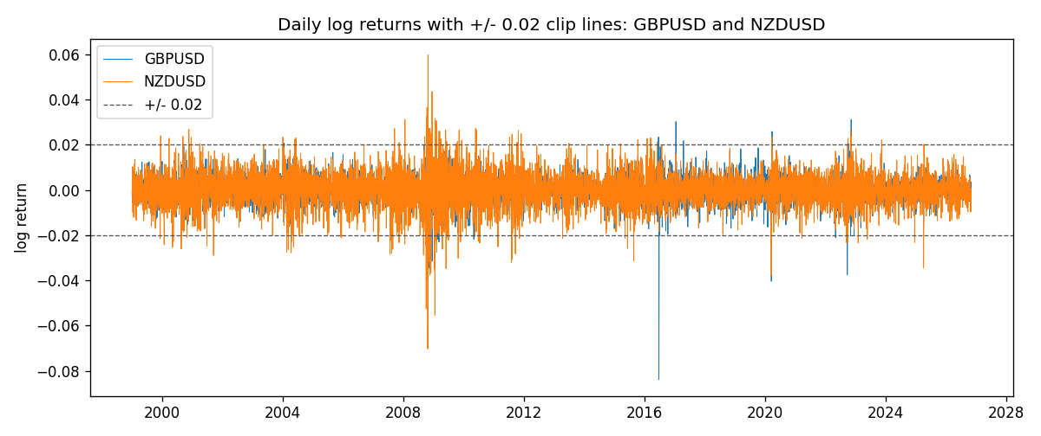
Log-return scatter with +/- 0.02 clip box
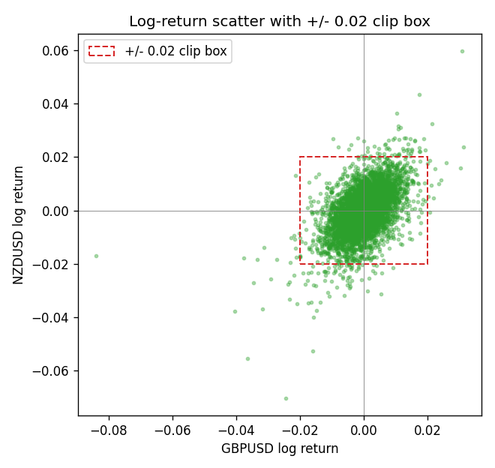

Data report
Every matched row that entered the clipped and raw correlations is stored in the sibling Excel workbook named GBPUSD-NZDUSD_Clipped_D1.xlsx. That file is the complete data archive for redrawing charts. Embedding all rows as a Word table is impractical at this length; the Word file holds the column list, column summaries, and the first and last 15 matched rows.
Columns: time, GBPUSD_open, NZDUSD_open, GBPUSD_high, NZDUSD_high, GBPUSD_low, NZDUSD_low, GBPUSD_close, NZDUSD_close, GBPUSD_tick_volume, NZDUSD_tick_volume, GBPUSD_spread, NZDUSD_spread, GBPUSD_real_volume, NZDUSD_real_volume, GBPUSD_log_return, NZDUSD_log_return, GBPUSD_log_return_clip_0p01, NZDUSD_log_return_clip_0p01, GBPUSD_log_return_clip_0p02, NZDUSD_log_return_clip_0p02, GBPUSD_log_return_clip_0p03, NZDUSD_log_return_clip_0p03
Column summaries (matched calculation rows)
column | count | mean | std | min | 25% | 50% | 75% | max
GBPUSD_open | 7203 | 1.5160351 | 0.21820856 | 1.06854 | 1.32502 | 1.51126 | 1.63163 | 2.1066
NZDUSD_open | 7203 | 0.65617721 | 0.10827592 | 0.3913 | 0.59107 | 0.6683 | 0.72469 | 0.88218
GBPUSD_high | 7203 | 1.5223294 | 0.21877071 | 1.08366 | 1.3298 | 1.51797 | 1.63833 | 2.1161
NZDUSD_high | 7203 | 0.66009189 | 0.10877133 | 0.3961 | 0.594565 | 0.67188 | 0.729235 | 0.88421
GBPUSD_low | 7203 | 1.5097156 | 0.21743942 | 1.03518 | 1.319525 | 1.50315 | 1.62431 | 2.0983
NZDUSD_low | 7203 | 0.65248767 | 0.1078698 | 0.3897 | 0.587935 | 0.66402 | 0.72082 | 0.87988
GBPUSD_close | 7203 | 1.5161019 | 0.21816437 | 1.06879 | 1.32515 | 1.51122 | 1.63196 | 2.1065
NZDUSD_close | 7203 | 0.65624807 | 0.10827144 | 0.3907 | 0.591395 | 0.6683 | 0.724915 | 0.8822
GBPUSD_tick_volume | 7203 | 94800.961 | 153533.35 | 62 | 9991 | 52873 | 91772.5 | 1273370
NZDUSD_tick_volume | 7203 | 68552.383 | 123030.52 | 16 | 5500.5 | 33815 | 58467.5 | 1127682
GBPUSD_spread | 7203 | 26.976121 | 19.194852 | 0 | 11 | 20 | 50 | 50
NZDUSD_spread | 7203 | 30.373178 | 25.676979 | 0 | 9 | 17 | 50 | 80
GBPUSD_real_volume | 7203 | 3.5551025e+09 | 8.4426509e+10 | 0 | 0 | 0 | 0 | 2.4038164e+12
NZDUSD_real_volume | 7203 | 1.6657093e+10 | 8.4881524e+10 | 0 | 0 | 0 | 0 | 2.705649e+12
GBPUSD_log_return | 7203 | -2.372e-05 | 0.00564203 | -0.08388241 | -0.00312422 | 3.221e-05 | 0.0031735 | 0.03112653
NZDUSD_log_return | 7203 | 5.29e-06 | 0.00764545 | -0.07027433 | -0.00426254 | 0.00021291 | 0.00457891 | 0.05966839
GBPUSD_log_return_clip_0p01 | 7203 | 1.495e-05 | 0.00484073 | -0.01 | -0.00312422 | 3.221e-05 | 0.0031735 | 0.01
NZDUSD_log_return_clip_0p01 | 7203 | 9.986e-05 | 0.00591309 | -0.01 | -0.00426254 | 0.00021291 | 0.00457891 | 0.01
GBPUSD_log_return_clip_0p02 | 7203 | -9.4e-07 | 0.00542561 | -0.02 | -0.00312422 | 3.221e-05 | 0.0031735 | 0.02
NZDUSD_log_return_clip_0p02 | 7203 | 3.996e-05 | 0.00720426 | -0.02 | -0.00426254 | 0.00021291 | 0.00457891 | 0.02
GBPUSD_log_return_clip_0p03 | 7203 | -1.159e-05 | 0.00553454 | -0.03 | -0.00312422 | 3.221e-05 | 0.0031735 | 0.03
NZDUSD_log_return_clip_0p03 | 7203 | 1.818e-05 | 0.00749434 | -0.03 | -0.00426254 | 0.00021291 | 0.00457891 | 0.03
First 15 matched rows (selected columns)
time | GBPUSD_close | NZDUSD_close | GBPUSD_log_return | NZDUSD_log_return | GBPUSD_log_return_clip_0p02 | NZDUSD_log_return_clip_0p02
1999-01-05 | 1.6547 | 0.5372 | -0.0028966287 | -0.0018597736 | -0.0028966287 | -0.0018597736
1999-01-06 | 1.6537 | 0.5383 | -0.00060452184 | 0.0020455609 | -0.00060452184 | 0.0020455609
1999-01-07 | 1.6502 | 0.5417 | -0.002118709 | 0.0062963171 | -0.002118709 | 0.0062963171
1999-01-08 | 1.6405 | 0.5414 | -0.0058954193 | -0.00055396548 | -0.0058954193 | -0.00055396548
1999-01-11 | 1.6312 | 0.547 | -0.0056851331 | 0.010290425 | -0.0056851331 | 0.010290425
1999-01-12 | 1.6349 | 0.5441 | 0.0022657001 | -0.0053157489 | 0.0022657001 | -0.0053157489
1999-01-13 | 1.6499 | 0.5387 | 0.0091330396 | -0.0099742238 | 0.0091330396 | -0.0099742238
1999-01-14 | 1.6531 | 0.5386 | 0.0019376331 | -0.00018564931 | 0.0019376331 | -0.00018564931
1999-01-15 | 1.6502 | 0.5382 | -0.0017558204 | -0.00074294208 | -0.0017558204 | -0.00074294208
1999-01-18 | 1.6522 | 0.5372 | 0.0012112405 | -0.0018597736 | 0.0012112405 | -0.0018597736
1999-01-19 | 1.6553 | 0.5382 | 0.0018745281 | 0.0018597736 | 0.0018745281 | 0.0018597736
1999-01-20 | 1.6472 | 0.5404 | -0.0049053846 | 0.0040793678 | -0.0049053846 | 0.0040793678
1999-01-21 | 1.6524 | 0.5426 | 0.0031518998 | 0.0040627941 | 0.0031518998 | 0.0040627941
1999-01-22 | 1.6565 | 0.5361 | 0.0024781662 | -0.012051689 | 0.0024781662 | -0.012051689
1999-01-25 | 1.6585 | 0.5342 | 0.0012066366 | -0.0035504102 | 0.0012066366 | -0.0035504102
Last 15 matched rows (selected columns)
time | GBPUSD_close | NZDUSD_close | GBPUSD_log_return | NZDUSD_log_return | GBPUSD_log_return_clip_0p02 | NZDUSD_log_return_clip_0p02
2026-10-13 | 1.32534 | 0.56127 | 0.0036434319 | 0.0047326165 | 0.0036434319 | 0.0047326165
2026-10-14 | 1.31884 | 0.55918 | -0.0049164679 | -0.0037306483 | -0.0049164679 | -0.0037306483
2026-10-15 | 1.32757 | 0.56185 | 0.0065976411 | 0.0047634855 | 0.0065976411 | 0.0047634855
2026-10-16 | 1.33257 | 0.56509 | 0.0037592051 | 0.0057501001 | 0.0037592051 | 0.0057501001
2026-10-19 | 1.33024 | 0.56616 | -0.0017500314 | 0.0018917133 | -0.0017500314 | 0.0018917133
2026-10-20 | 1.3377 | 0.56827 | 0.0055923442 | 0.0037199341 | 0.0055923442 | 0.0037199341
2026-10-21 | 1.33937 | 0.57003 | 0.0012476328 | 0.0030923331 | 0.0012476328 | 0.0030923331
2026-10-22 | 1.33967 | 0.56815 | 0.00022396082 | -0.0033035227 | 0.00022396082 | -0.0033035227
2026-10-23 | 1.33684 | 0.56991 | -0.0021146949 | 0.0030929853 | -0.0021146949 | 0.0030929853
2026-10-26 | 1.33359 | 0.56826 | -0.0024340661 | -0.0028993932 | -0.0024340661 | -0.0028993932
2026-10-27 | 1.33044 | 0.56811 | -0.0023648393 | -0.00026399852 | -0.0023648393 | -0.00026399852
2026-10-28 | 1.33254 | 0.56261 | 0.0015771808 | -0.0097283914 | 0.0015771808 | -0.0097283914
2026-10-29 | 1.33733 | 0.56296 | 0.0035881935 | 0.00062190714 | 0.0035881935 | 0.00062190714
2026-10-30 | 1.33913 | 0.56307 | 0.0013450605 | 0.00019537668 | 0.0013450605 | 0.00019537668
2026-11-02 | 1.3406 | 0.56161 | 0.0010971256 | -0.0025962955 | 0.0010971256 | -0.0025962955

